**PySystemTrade Backtests.**

This is the Rob Carver’s system with some modifications to make backtests without carry data.

In order to Back tests strategies, you must follow next instructions. It is assumed that Git is installed on your computer. You should also have administrator permissions for installing the different components.

1. Git clone [this](https://github.com/pauljherrera/pysystemtrades-backtests) repository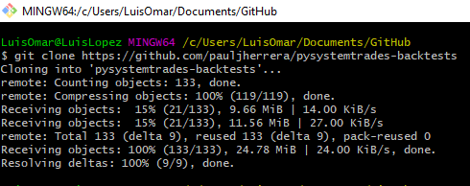
2. We strongly recommend creating a virtual environment, but this step is optional.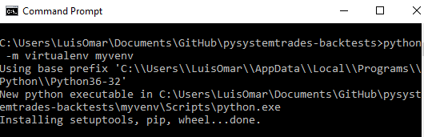
3. CD into the repo you just clone, activate the virtual environment (If you create one), then, go to PySystemTrade folder and run: **python setup.py develop.** This will install PySystemTrade into your system.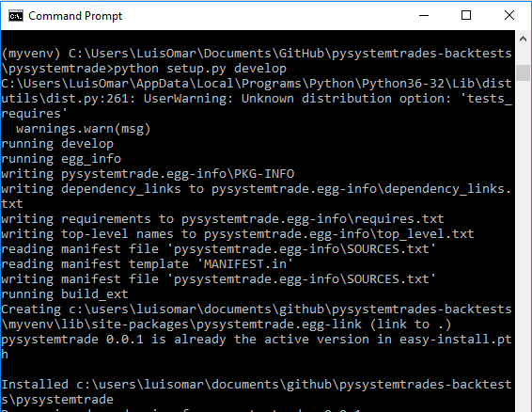
4. From now on, you could just run futures_system.py located in PySystemTrade-Backtests folder, and this will proceed to make the back test with legacy data provided by Rob Carver. You can provide your own data, but it must follow certain rules, like:
   * Must start with the asset name in capital letter i.e.: EDOLLAR.
   * Must end with _price.csv suffix.
   * Must have two columns, datetime and price.
   * The data must be stored in: ***pysystemtrade-backtests/pysystemtrade/private/nocarrydata***
5. You can change the configuration of the system, by changing nocarryconfig2.yaml file located in **PySystemTrade/Private** folder, we recommend being comfortable with the system before changing any of these config. With this option, you can choose from trading rules to forecast weights.